420 Time Tracker Manual

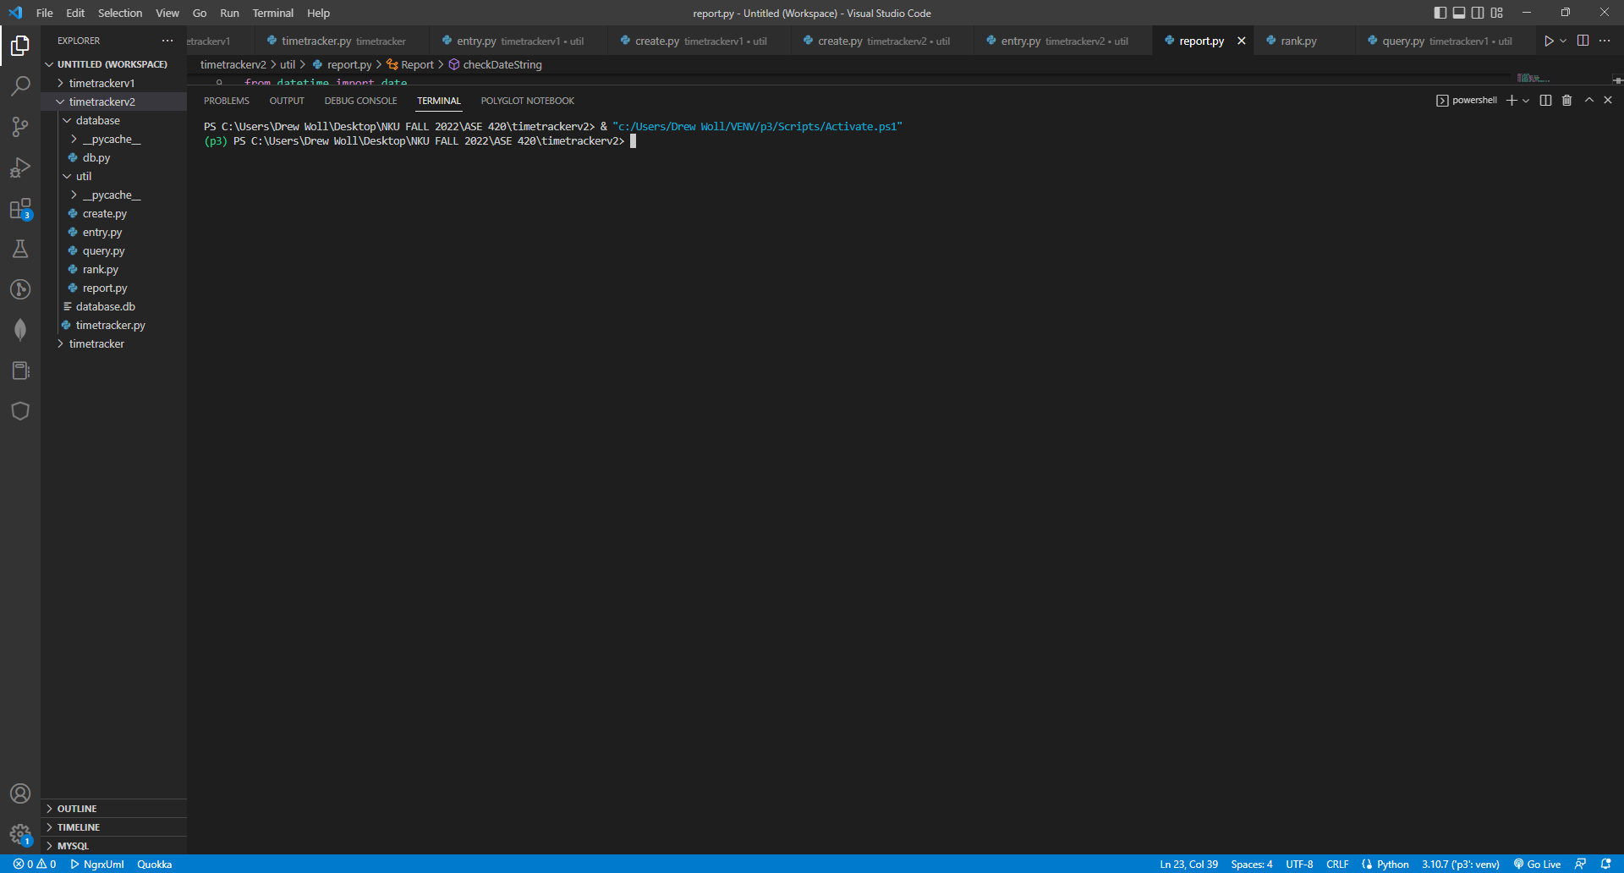

Begin by activating your VENV.

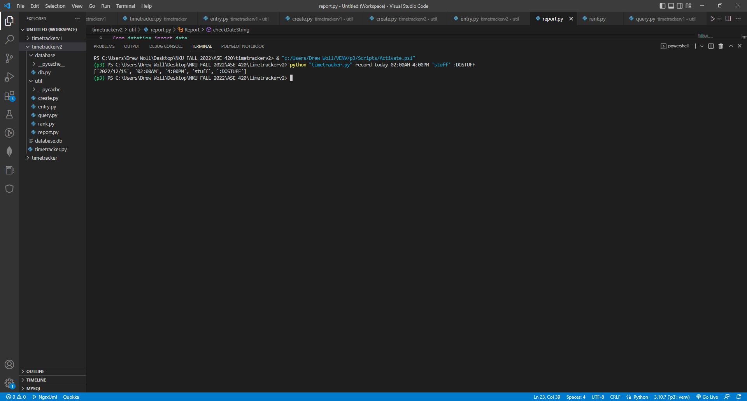

To process any kind of command in the application, the common must be preceded by ‘python “timetracker.py”’. In this picture above, you can see the word following this is “record”. This word will always determine what kind of action you want to take place. With “record”, we are trying to create an entry in the database. After clicking “Enter”, this entry will be displayed in its object array to the user to confirm it has been added.

To query any information, such as the task, tag, or date of an entry, users input “query” as their first command word. The following date, task, or tag that is inputted is the value that will be searched for in the database.

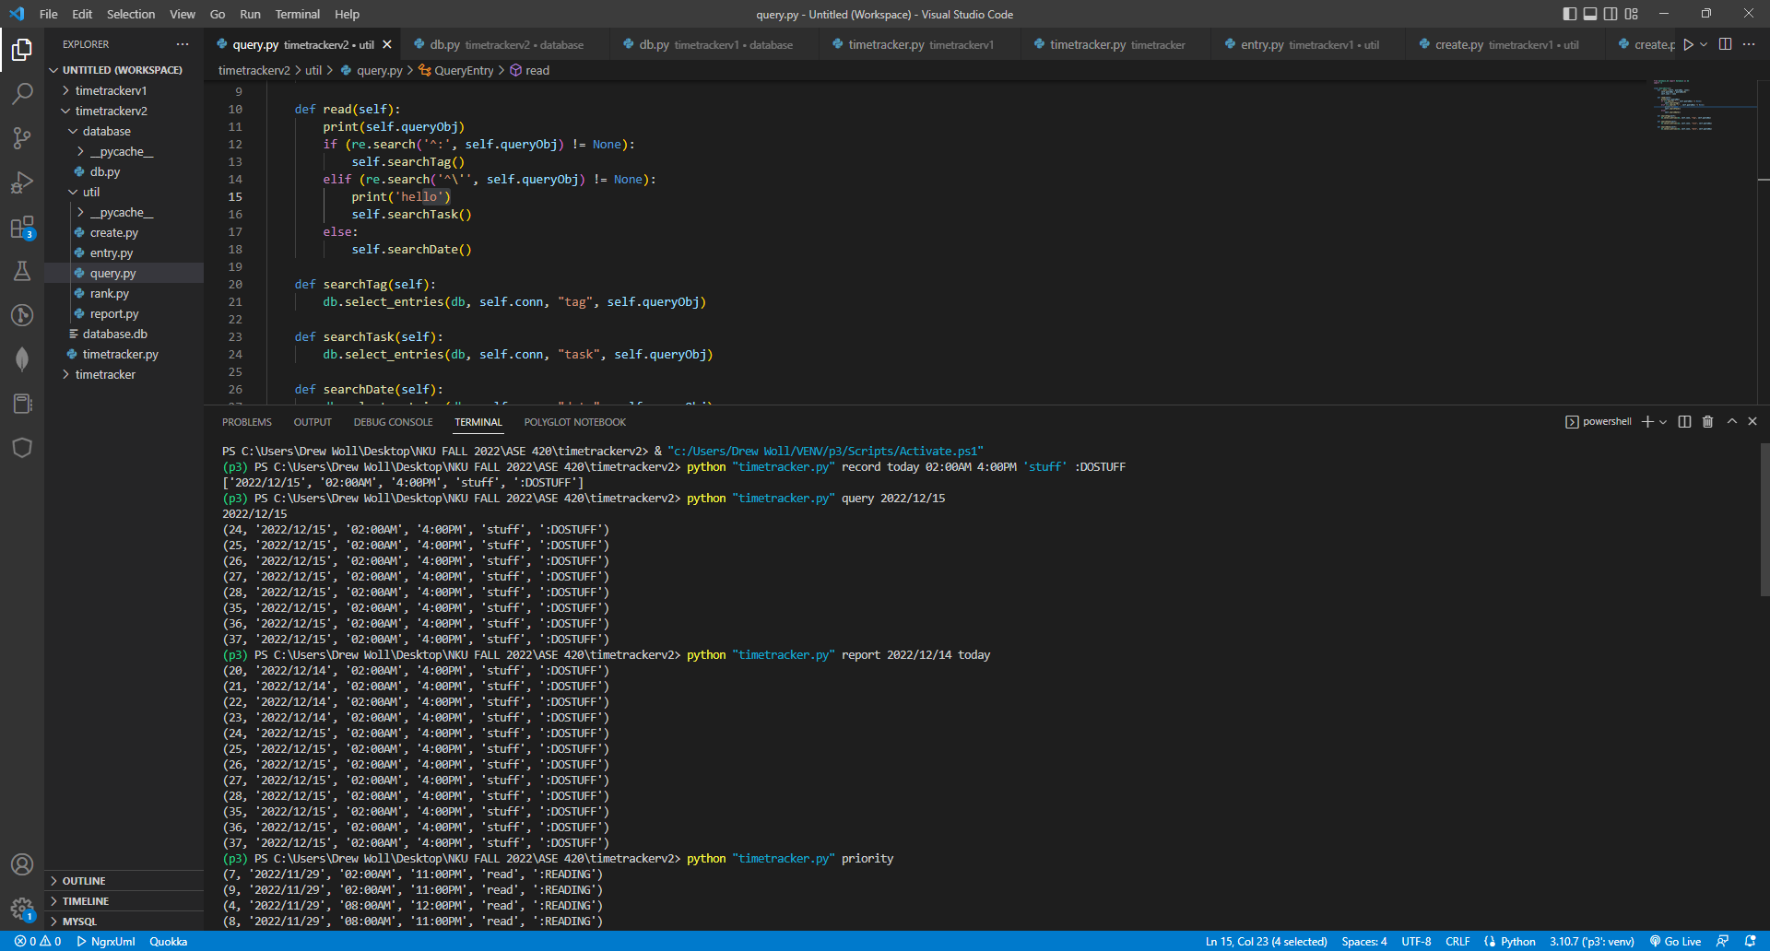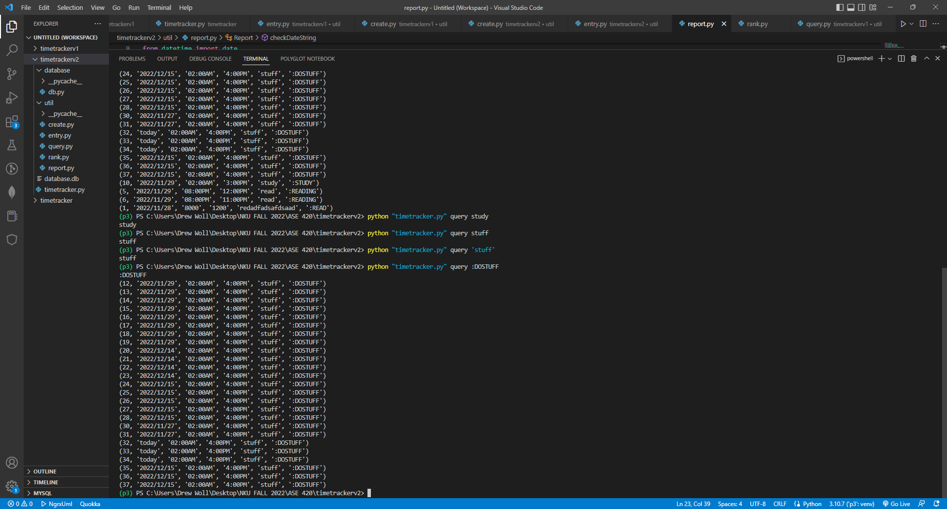

Users may wish to get a report of entries created within a specific time period. Using the word “report” as the first command word will provide this functionality. The following 2 commands must be either dates or the word “today”, which will be translated into the current date.

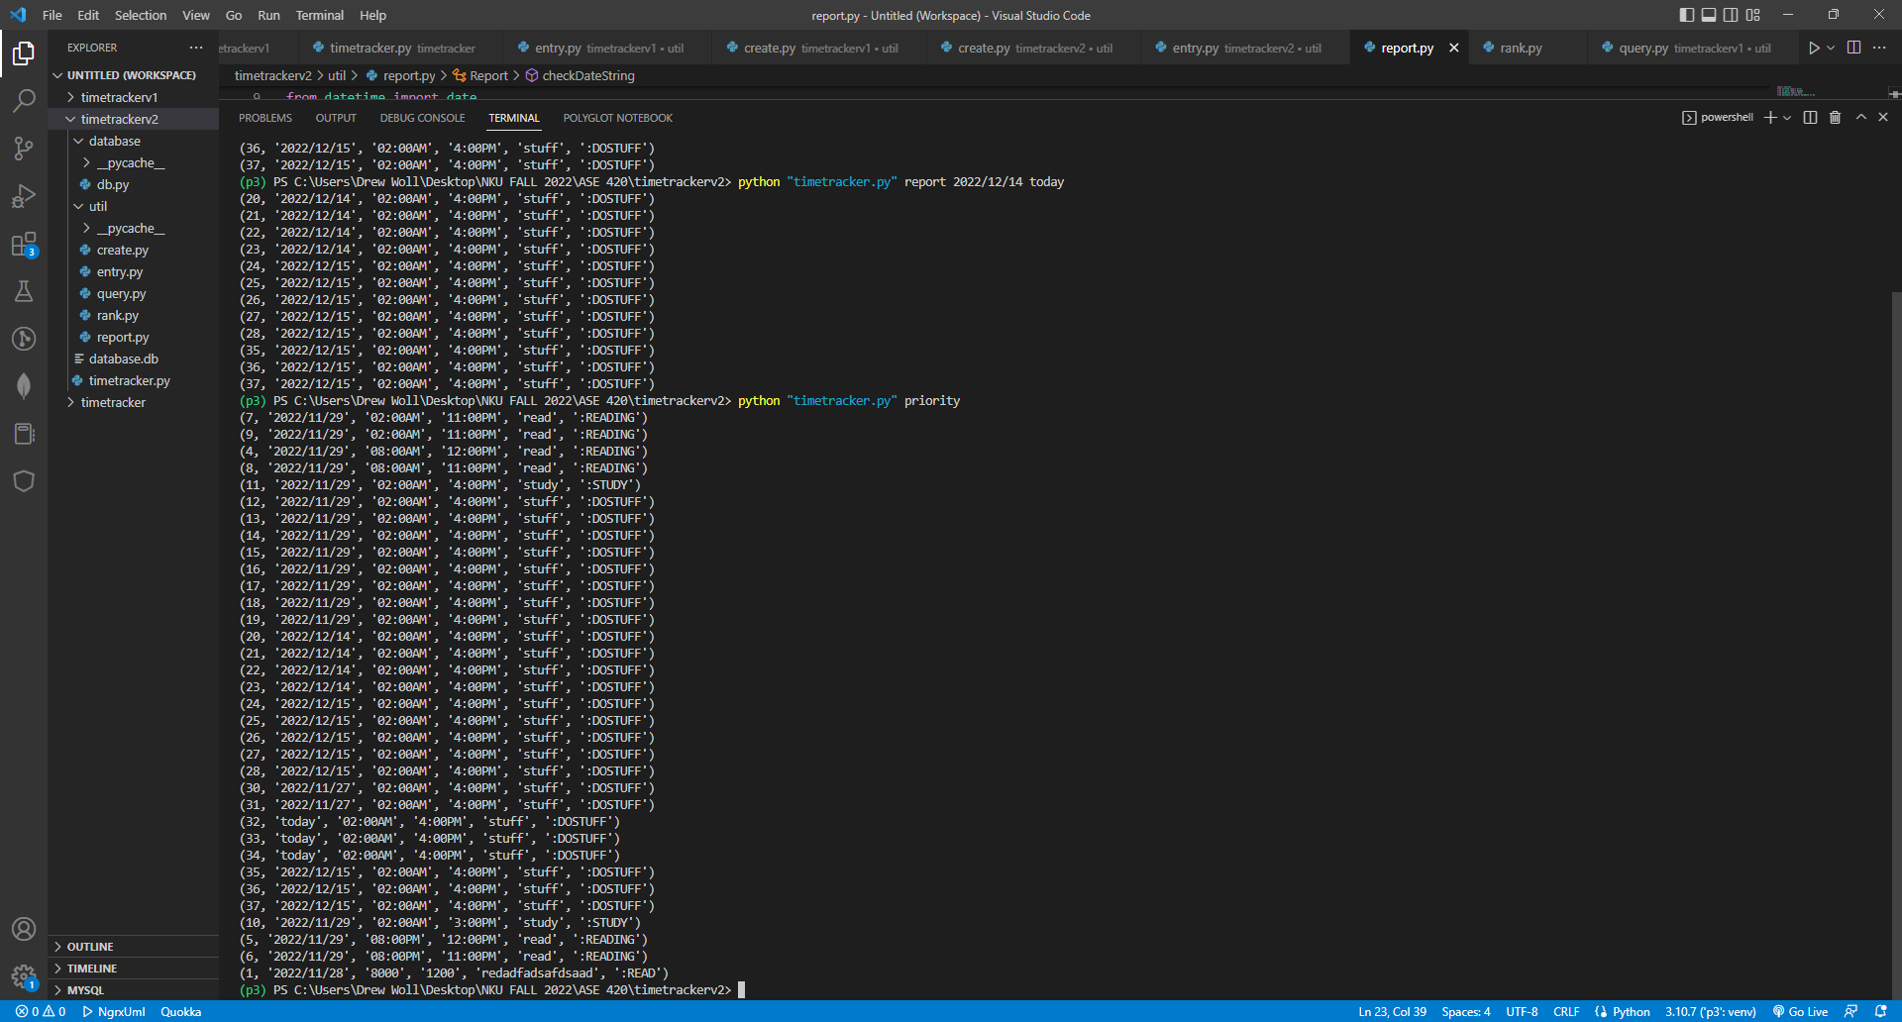

It could be useful for users to see a list of entries ranked by greatest amount of time difference between the values for the starting and ending times of an entry. Essentially, users will see a list of entries ranked by the amount of time being spent on them. The command word “priority” followed by no other commands results in this list being displayed to the user.

